CCMCS402: COMPUTER SKILLS

Date: 26th Nov 2025
Period: 08:00AM – 10:00AM

SCHOOL COMPREHENSIVE ASSESSMENT
SECTOR: ALL
RTQF LEVEL: 4
TRADES: NIT, FAD, WOT, and BDC
55

MARKS:
DURATION: 2 HOURS
INSTRUCTIONS TO CANDIDATES:
- This Exam paper is composed of TWO (2) Sections (A, and B). Follow the instructions given below, and answer the indicated questions for a total of 55marks
Section A: Attempt all questions of THREE (3) parts. (35 Marks)
Section B: Attempt only 2 questions of your choice (20 Marks)
2. Use only blue pen or black pen.

SECTION A: 35 Marks
PART A: Choose the correct answer (Multiple Choice):
- Which of the following best defines an Operating System?
A. A program used only for gaming
B. A system software that manages computer hardware and software
C. A device used to store data
D. A special type of printer
- An operating system acts as a bridge between the user and the ______.
A. Application
B. Network
C. Internet
D. Hardware
- Which one is a feature of an operating system?
A. Car acceleration
B. Weather prediction
C. Multi-tasking
D. Mobile charging
- A computer freezes because too many programs are running. Which OS function is MOST responsible?
A. Memory management
B. Security management
C. File management
D. Device management
- Memory management in an OS mainly deals with:
A. Storing movies
B. Handling and allocating RAM
C. Printing documents
D. Repairing hardware
- Which OS function is MOST important for preventing unauthorized access?
A. Device management
B. Security management
C. File management
D. Memory management
- What is the difference between a file and a folder in a computer's file system?
- A file is a container for storing data, while a folder is a collection of files.
- A folder is a container for storing data, while a file is a collection of folders.
- A file and a folder are the same thing; they both store data.
- A file is a physical object, while a folder is a digital object.
- Which of the following is NOT an example of an operating system?
  - Windows 10
  - Mac OS
  - Linux
  - Google - Chrome
- The core part of the OS that communicates with hardware is called:
A. File system
B. Browser
C. Kernel
D. Desktop
- A GUI mainly uses:
A. Commands only
B. Icons and windows
C. Only text files
D. Only voice instructions
PART B: Answer by True / False
- GUI requires typing commands to run programs. False
- Network OS is used to control and manage computers that are connected together. True
- The OS handles memory allocation to different applications True
- An embedded OS is used in general-purpose computers like laptops. False
- Time-sharing OS allows multiple users to share CPU time. True
- A soft real-time OS guarantees strict timing deadlines. False
- File management includes renaming, moving, and deleting files. True
- The kernel is responsible for connecting the computer to the internet. False
- The operating system helps the user to interact with the computer. True
- A file extension can help you determine the format and type of a file. True
PART C: Match the OS Characteristic to Its Description
1.
Column A (OS Characteristics & Shortcuts) | Column B (Descriptions)
A. Single-user OS | 1. Allows only one user to work on the computer at a time.
B. Multi-user OS | 2. Allows two or more users to use system resources at the same time.
C. Multitasking OS | 3. Enables one user to run multiple programs simultaneously.
D. Multiprogramming OS | 4. Loads several programs in memory and lets CPU switch between them.
E. Multiprocessing OS | 5. Uses two or more processors to perform tasks at the same time.
F. Real-Time OS (RTOS) | 6. Provides instant responses and meets strict timing deadlines.
G. Distributed OS | 7. Controls multiple computers and makes them act as one system.
H. Time-Sharing OS | 8. Shares CPU time among many users using time slices.
I. Shortcut: F2 (Rename) | 9. Used to rename a selected file or folder.
J. Shortcut: Delete Key (Delete file) | 10. Used to delete a selected file or folder.

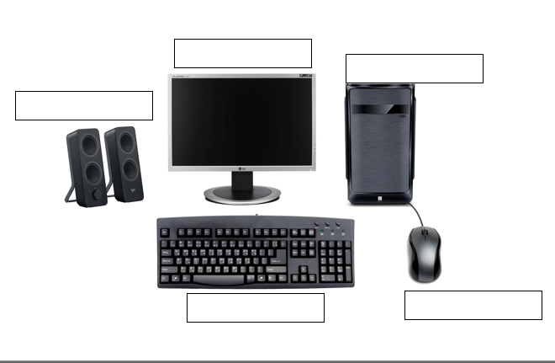
2. Write the names of each computer part (5 marks)

Keyboard

Mouse

CPU: PC-Case

Monitor / Screen

Speakers

QUESTION 1: Fashion Design – Model Answers
a) Creating files (3 marks)
- Right-click on the desktop → select New Folder → name it Fashion_Project.
- Open the folder.
- Right-click → New → Microsoft Word Document → name it Sketch1.docx.
- Repeat the steps to create Sketch2.docx and Sketch3.docx.
b) Copy and paste (2 marks)
- Right-click Sketch1.docx → select Copy.
- Open Backup_Sketches folder.
- Right-click inside the folder → Paste.
c) Editing the file (3 marks)
- Double-click Sketch2.docx to open it.
- Type the new fabric description.
- Click File → Save or press Ctrl + S.
d) Selecting and moving files (2 marks)
Adjacent or non-adjacent:
- Hold Ctrl and click Sketch1.docx and Sketch3.docx.
- Right-click → Cut.
- Open Final_Designs → Right-click → Paste.

QUESTION 2: Building & Construction – Model Answers
a) Creating files (3 marks)
- Create a folder named BDC_Project.
- Open it → Right-click → New → Excel Workbook → name it FloorPlan.xlsx.
- Repeat to create MaterialList.xlsx and Budget.xlsx.
b) Copy/Paste (2 marks)
- Right-click MaterialList.xlsx → Copy.
- Open BDC_Backup → Right-click → Paste.
c) Editing file (3 marks)
- Open Budget.xlsx.
- Edit the cement cost inside the appropriate cell.
- Click Save or press Ctrl + S.
d) Select non-adjacent items (2 marks)
- Hold Ctrl and click FloorPlan.xlsx and Budget.xlsx.
- Right-click → Cut.
- Open BDC_Final → Right-click → Paste.

QUESTION 3: General Project Management – Model Answers
a) Creating files (3 marks)
- Create folder All_Projects.
- Inside it, right-click → New → Word Document.
- Name files: FAD_Project.docx, BDC_Project.docx, WOT_Project.docx, NIT_Project.docx.
b) Copy folder to USB (2 marks)
- Insert USB → open This PC.
- Right-click the All_Projects folder → select Copy.
- Open USB drive Backup_2025 → Right-click → Paste.
c) Editing file (3 marks)
- Open FAD_Project.docx.
- Type the new update.
- Click Save.
d) Selecting and moving (2 marks)
- Hold Ctrl and click BDC_Project.docx and WOT_Project.docx.
- Right-click → Cut.
- Open Technical_Projects → Paste.

